Ham Supply Yaesu Illuminator Installation Instructions
- There are several rotor control boxes the Yaesu Illuminator board will mount in. Presently the Yaesu Illuminator has been installed, tested and confirmed operational in these control units: G-800DXA, G-1000DXA, G-2800DXA, G-800DXC, G-1000DXC and G-2800DXC. Also confirmed fit in G-800SA, G-800SDX, G-1000SDX and G-2800SDX controllers. As we confirm operational success in “unlisted” controllers, we will update these instructions and our Website accordingly.
- Unplug the rotator control box from the mains power supply. Unplug the rotator antenna cabling plug on the rear of unit. Utilize a clear and open workbench, table, etc. for installation of your Yaesu Illuminator Board.
- Remove 7 Phillips screws on the rotator control box. 2 from the back panel, 2 from the sides, 3 from the front bottom. Set those 7 screws aside as you will reuse them in the reassembly. Note, all 3 locations use different size screws.
- Gently pull apart the control box with two hands. The “face” including the compass meter in one hand, the outer rotator control “shell” with the other. There is no need to unplug any connectors or disconnect any block connectors to boards at this time. With the “halves” separated, and although a minimal working condition exists, the wiring harnesses in every unit we tested were long enough that our technicians had ample room to install the Yaesu Illuminator board without unbundling connectors or unmounting connector blocks to board. If you feel you need more room, remove the two countersunk Phillips head screws holding the metal board to the top front plastic housing.
- On the inner face “half”, locate and remove 2 Phillips head screws that are used for mounting the existing compass style meter to the plastic front bezel. These 2 screw positions are where the Yaesu Illuminator will mount. Picture #1. You may discard those 2 Phillips panhead screws as they will be replaced with Yaesu Illuminator Phillips panhead screws included with your new board.
- If your control unit utilizes the front “Start” or “Preset” button, visually inspect the backside of that printed circuit board and snip any excess wires protruding from above their board solder joints. Note, the reason for this step is that your new board will partially lay over the Start/Preset Button Board - by snipping excess and unused wire from above the solder joints, this gives the Yaesu Illuminator Board extended clearance.
- With the 3 Clear LED’s facing the compass meter (under the compass meter metal mount) and with the components on the Yaesu Illuminator Board facing UP, place the Yaesu Illuminator Board across these two mounts. Double check that the two nylon washers remain under the board. Proceed to tighten the two Phillips panhead screws provided. Do not over tighten. Take a few moments to inspect your work and answer “yes” to these questions. “Are the 3 LED’s on the Yaesu Illuminator facing the meter compass and under the compass meter metal mount? Is the new board laying flat? Are the components (diode, resistor, etc.) facing UP and away from the Start/Preset Button Board? Are the 2 nylon washers under the board? Are the 2 mounting screws snug?”
- If you answered yes to all questions, proceed to locate the 2 wires going to the upper left of the compass meter (viewing from the front of compass meter). Viewing from the rear of the face half, these 2 wires are in the upper right top corner of the control box. These 2 wires are the power wires to the original hi-intensity, non-serviceable bulb you are replacing. The bulb is not visible, but these 2 feed wires are. There is no other wiring near these 2 wires. Snip those two wires as close as possible to the bulb. These are the two wires that connect to the black and red Yaesu Illuminator Board wires. For DXA (Picture #3) controllers the 1st wire in the upper connector block is Positive, the 2nd is Negative. Mark the 2nd wire negative with a small piece of black tape. For SDX controllers (Picture #4), these wires can be hooked either way to the red and black Illuminator board connectors as the SDX controllers utilize 12 VAC.
- For DXA controllers connect the RED Positive wire on the Yaesu Illuminator to the 12VDC Positive, the BLACK Negative on the Yaesu Illuminator wire to the Negative (black tape). For SDX controllers you may hook them either way as the SDX controllers utilize 12 VAC. At this point with the front halves separate and all wiring clear of obstructions, check that your Yaesu Illuminator LED board is working and hooked up correctly. Plug unit in to the mains, depress the Power button and note the 3 LED’s on the Yaesu Illuminator Board light (for DXA controllers, if your connections are reversed, the LED’s will not light as they are diode protected). Immediately unplug from mains and continue with permanent wire splices. Some technicians utilize solder and shrink tube for their connections; others strip and crimp. We leave the 12V connections to whatever type of connection you are personally comfortable with. After splicing, check to make sure the wires do not interfere with any components.
- Slide the 2 halves together and reinstall the 7 screws - 2 in the back, 2 on the sides and 3 on the bottom front. You have completed the installation of your Yaesu Illuminator LED Board!
High resolution pictures are available at: http://www.hamsupply.com/support/ under “Yaesu Illuminator”
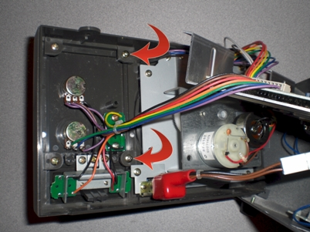 #1 (Illuminator Mounting Holes)

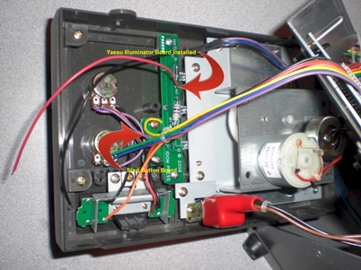 #2 (Illuminator mounted)
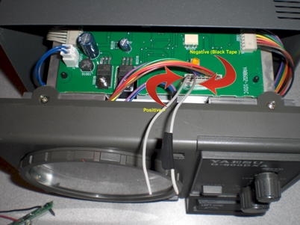 #3 (+ & - to Yaesu Illuminator Board DXA Boxes)

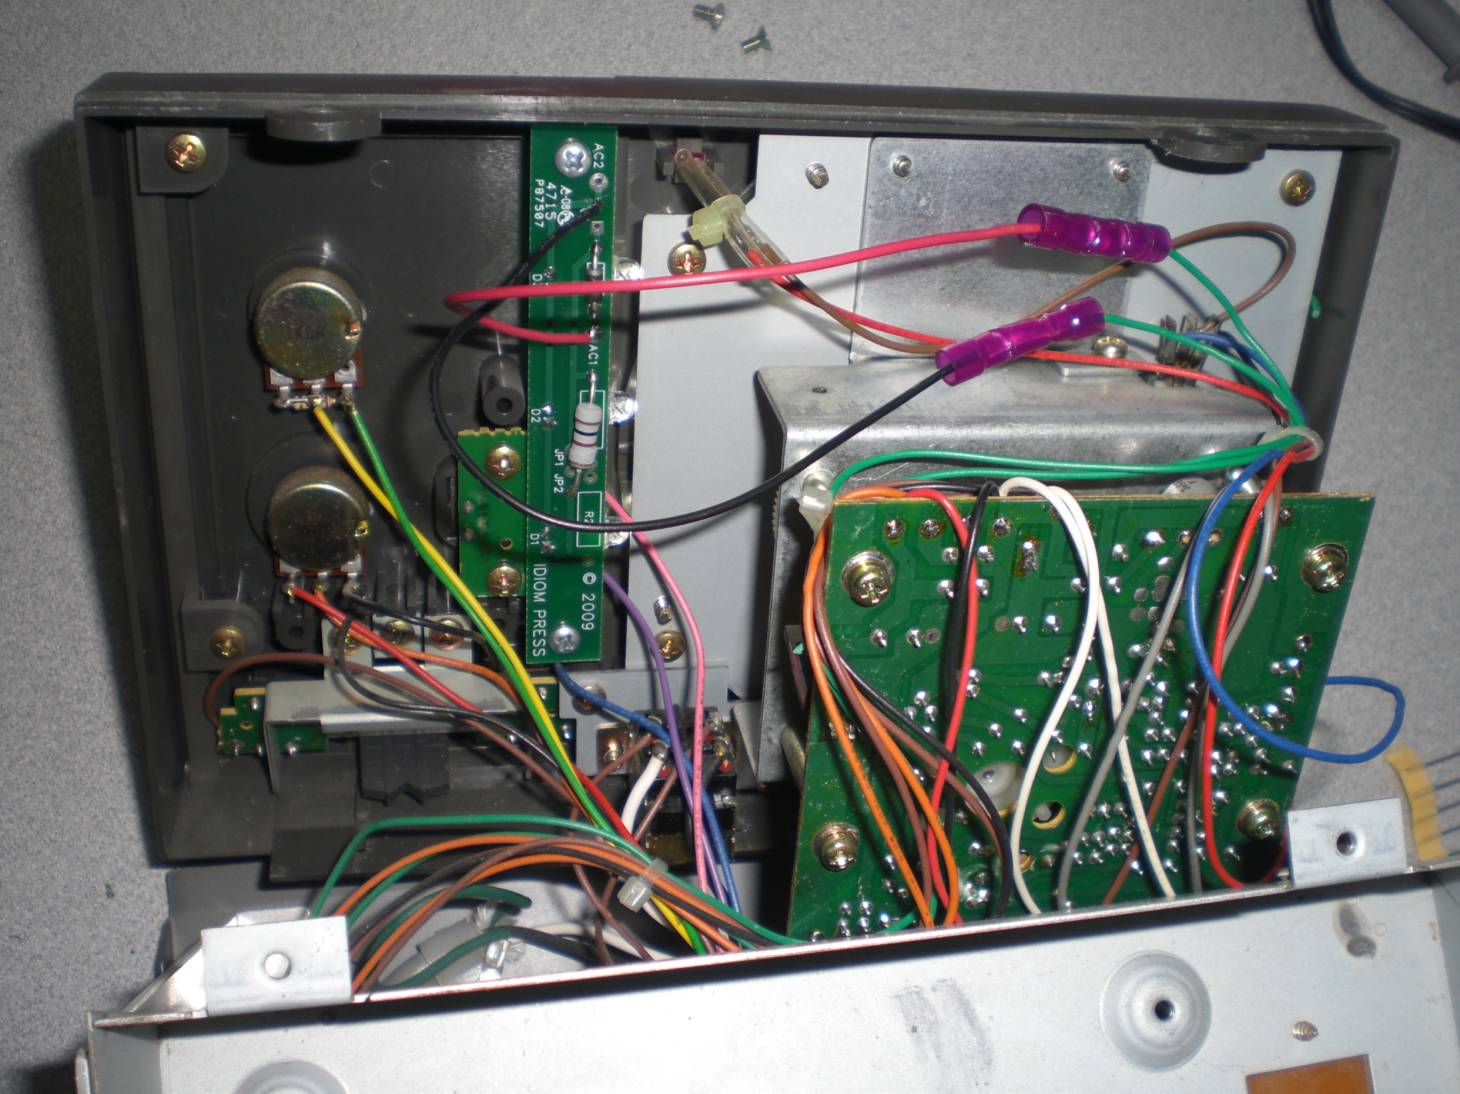 #4 (12VAC to Yaesu Illuminator SDX Boxes)

