Installation and User Instructions
RotorCard DXA – Yaesu DXA Series Rotors

Note that this model of RotorCard works only for Yaesu DXA or DXC series rotors, which include preset capability. If your rotor is not a DXA or DXC series, this card will not work.

With the RS-232 option, RotorCard accepts rotation commands from any computer or terminal with an RS232 port. This makes your rotor compatible with any of the popular logging and contest programs that offer compatibility with the Rotor-EZ or the HyGain DCU-1 protocols.
RotorCard DXA is specially designed for Yaesu DXA series rotors, and fully supports both the overlap mode of the rotor and the speed slow down feature of your rotor.

Calibration

Prior to installation of your RotorCard DXA, you must first calibrate the card to the rotor. Make sure the rotor is unplugged from the power source. Then, remove the cover of the control box. To do so, remove the screws holding the four feet, and the two screws in the rear upper corners of the control box. On the rear panel of the control box, above the power cord near the top, is a small metal access panel held in place by two screws. Remove this panel and the screws.

Note that the DXA RotorCard assembly includes three cables – an RS232 cable, a cable terminated by a mini-DIN plug, and a wire with a test clip.

Also note the two trim resistors on the DXA RotorCard board. See that the two trim resistors are each presently set at the center of their range. Also insure that you have a suitable screwdriver for adjusting them later.

Plug the mini-DIN connector into the matching mini-DIN jack on the rear of the rotor control box. Next, plug the RS-232 connector from your DXA RotorCard to a matching RS232 connector on your computer.

Look at the top of the control box from the rear. At the right front of the top of the control, as viewed from the rear, you will see two voltage regulators screwed to the circuit board. The left regulator is a 7812A, and is identified by the label Q1038. The right regulator is a 7808A and is identified as Q1001. Clip the test clip from the DXA RotorCard onto the rightmost pin of the right voltage regulator, which is the 7808A marked as Q1001. The photo on page 4 will help locate the correct pin.

Prior to calibration, you must determine whether you are using a north-centered rotor or a south-centered rotor. Most stations use north-centered rotors. If there is any question as to which yours is, look at the front of your rotor, and see what the direction is at the top of the bearing circle. If it is north, your rotor is north-centered.

If this is the case, proceed on to the next step. If your rotor is south centered, it is necessary to cut a jumper on the DXA RotorCard board to attain proper operation, using the following instruction. Find the CPU on the DXA RotorCard. This is the largest integrated circuit on the board. Note that at the end of the CPU on the right side a small wire jumper sticking up. If you are using a south centered system, this jumper must be cut – use a sidecutter, and make sure the two wires that have been cut apart are well separated from each other.

Now, make sure that your DXA RotorCard is not touching anything metallic which might lead to possible shorts. Plug your Rotor control back in, and begin the following calibration procedure.

- To calibrate your RotorCard you will need to run a terminal emulator program on your computer, such as HyperTerminal which comes with Windows. Or, a good shareware terminal program is “Simple Terminal” and can be found at http://www.c-kubed.com/ .

- Use the following settings: 4800 baud, 8 data bits, no parity, and one stop bit. These settings are often abbreviated “4800,8,N,1”. Make sure your terminal program is addressing the COM port that your cable is plugged into. Set Flow Control to “none”.

- Turn the rotor control back on and manually rotate your rotor heading to 270 degrees.

- Type the letter “V” on your computer. Make sure you use a capital “V”, as this is case sensitive. RotorCard should respond with “Idiom Press” and copyright data. If you do not get a response, there is a problem. If that case, verify all connections, then see that the terminal settings above are correctly entered and that the terminal program is functioning properly. Make sure you are addressing the correct serial port.

- Send a capital “K”. The monitor screen should now quickly fill up with 3 digit numbers. The numbers should read somewhere between 230 and 300. (Note that if the numbers read between 50 and 130, your rotor is almost surely a south centered rotor. In this case refer back to page 1 of this instruction set.) The most recent number will be at the bottom of your screen.

- On the back of the rotor control box, you will find a potentiometer labeled “OUT VOL ADJ”. It is the potentiometer furthest to the right. With a small screwdriver, adjust the pot until you get approximately 270 as the bottom numbers on your computer screen. Any number between 265 and 275 is okay. This adjustment only affects your RotorCard, and does not affect the rotor calibration otherwise. (Note – if you have a south-centered rotor, adjust for 90 degrees instead of 270 degrees.)

- As you look at the DXA RotorCard board, note the two trim pot resistors near the back of the card. The left pot is R3, the right pot is R4. With a small screwdriver, adjust R3, while watching the numbers at the bottom of the computer screen. Adjust the pot until you get 270 (or 90 for a south-centered rotor). Because the position sensor is an analog wire-wound potentiometer, it may not be possible to get exactly 270. If not, get as close as possible.

- Manually turn the rotator to 90 degrees. Adjust R4 until the numbers at the bottom of the screen read 090. (If you have a south-centered rotor, set for and adjust for 270 degrees.) As before, it may not be possible to get 90 degrees (or 270 degrees) exactly; just get as close as possible. If you are unable to get close to the target, then read the next paragraph; if you did not have any trouble, go to step 10.

- If you have trouble reaching the target in the previous step, then you must begin again. (If you did not have trouble, then please go to step 10.) Please understand that the “OUT VOL ADJ” potentiometer makes large changes, and R3 and R4 on the RotorCard make small changes. “OUT VOL ADJ” can be adjusted so that no adjustment of R3 or R4 will calibrate the RotorCard. We suggest that you follow an alternate calibration procedure:

  - Begin the calibration procedure again by turning R3 and R4 so that they are in the middle of their ranges.
  - Manually turn the rotor to 0, 90, 180, and 270 degrees, and adjust “OUT VOL ADJ” so that a single “OUT VOL ADJ” setting is the most correct for all four directions, according to the numbers on the computer screen.
  - Go back to steps 7 and 8 to adjust R3 and R4.

- Now, send a lower case “k” from your keyboard to end the calibration program. This completes calibration of your DXA RotorCard.

- Test the rotor control function by sending the command: “AP1030;AM1;”. “AP1030 <CR>” may also work, depending on your computer. Verify that the antenna rotates the antenna to a bearing of 30 degrees.

Once again, turn off the control and disconnect the power plug. Unplug the cables coming from the DXA RotorCard, and temporarily remove the test clip going to the voltage regulator. You will now install the DXA RotorCard inside the rotor control box.

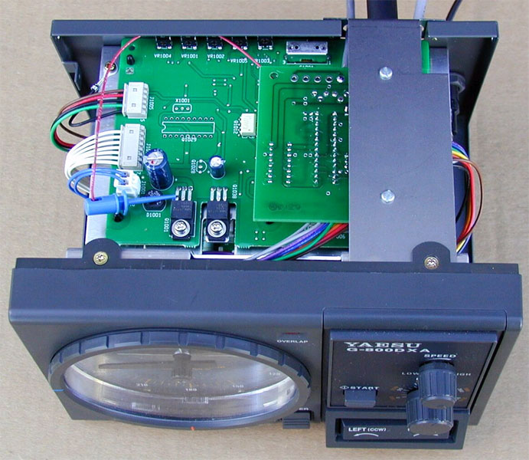

Looking down at the top of the control box from the front, note two Phillips head screws on tabs coming from the front panel ring. Remove the right screw. Now, hold the DXA RotorCard assembly so that its PC board is upside down, and the metal bracket is on top. Note that one end of the bracket has a slot, which is the front end, and that the other end is turned down, with the cables passing through holes. This is the rear end.

Press gently down on the Yaesu chassis on the right side, underneath where you removed the screw, and ease the DXA RotorCard bracket in between the chassis and the tab. Line the slot underneath the screw hole.

Wiggle the rear of the RotorCard bracket so that the rear access panel screw holes line up with the bracket. The RS232 cable and the mini-DIN cable should be sticking out from the bracket. The wire with the test clip should remain inside the box.

Replace the screw in the front, and then the two screws which formerly held the access cover.

Place the test clip back on the transistor pin as you did before. If you are competent at soldering, you may now wish to remove the test clip and instead solder the wire directly to the pin.

Now, reinstall the cover to the control box. Then, bend the Mini-DIN cable into a “U” and plug it into the Mini-DIN jack on the rear of the control. Plug the RS232 cable back to the computer. This completes Calibration and Installation.

Your rotor will now work with most logging programs and rotor aiming programs. Free programs that will work are available at:

http://www.qsl.net/k0bx (go to rotor control)
http://www.telepostinc.com/LP-Rotor-Html/index.html
http://www.qsl.net/dxview/

Select the “Rotor-EZ” command set if available; otherwise use “HyGain DCU-1”. RotorCard does not recognize the Yaesu command set. RotorCard accepts rotation commands from any computer or terminal with an RS232 port.

Important note: The program you are using must insert leading zeros into bearing commands, such as “009” degrees, instead of “9” degrees. Most programs are already configured this way, but some are not in their default mode, and in such cases you must change the default setting or your DXA Rotor-Card will not work properly.

Rotor-Card can also be commanded from any terminal having RS232 output, using the following configuration: 4800 baud, 8 bits, no parity, and 1 stop bit. (8,N,1) Flow Control must be off, or “None”. Note that upper case/lower case must be used as listed for the commands below to work:

"AP1xxx<CR>" sets target bearing to "xxx" degrees where xxx are three digits between 000 and 360, and executes. A typical command to rotate to 080 degrees would be AP1080<CR> Note that the <CR> is often labeled <Enter> on many keyboards.

"AP1xxx;" sets the target bearing but does not execute.
"AM1;" executes rotation to the bearing set by the "AP1xxx;" command
"AI1;" inquires current bearing; and responds with (000-359) degrees
";" terminates rotation

Our best advertising for our products is word of mouth – please be sure to tell your friends about our products. And we would very much appreciate reviews on the internet at sites such as
www.eham.net.

73!

Trouble Shooting

Check the 9-pin RS-232 connector: check for continuity from pin #2 at the computer end of the RS232 cable to PCB pad "B". Check for continuity from pin #3 to PCB pad "A" . Check for continuity from pin #5 to the metal tab on the three 3-terminal regulator on the RotorCard.
A failure here indicates a cable problem. If you encounter a failure, see if pins 2 and 3 are reversed. A null modem would correct this problem.

Verify FLOW CONTROL IS NONE (H/W flow will cause it to fail). Start terminal emulator set to: Baud Rate 4800, Data Bits 8, Parity None, Stop Bits 1, and Flow None. Verify voltage at pad "A" is -7.7vdc (This could easily very by %10)

Hold uppercase 'V' key (using CAPS LOCK) and verify that the voltage at pad "A" is -7.3vdc (This could easily vary by %10, but the voltage should be significantly less than the prior step)

A failure here indicates a cable or PC problem.

Remove the processor U1. Using a small piece of wire short U1 pins 17 and 18. Start the terminal emulator (select the correct serial port, disable terminal ECHO), type on the keyboard and verify that what is typed is echoed to the display. This "wrap back mode" verifies that the serial communication is good all the way to the processor. Remove the jumper wire and replace U1.

Verify voltage at U2-12 is 5.0vdc. Hold ';' key and verify voltage at U2-12 is 4.9vdc
Verify U2-2 is 10 +/- 1.5 vdc. Verify U2-6 is -10 +/- 1.5 vdc. A failure here indicates a PCB problem.

Warranty

Your DXA RotorCard is warranted against defects in material and workmanship for 90 days from the date of purchase from Ham Supply or from an authorized Ham Supply dealer.

This warranty does not cover damage or failure caused by or attributable to Acts of God (such as nearby lightning strikes), abuse, misuse, improper or abnormal usage, faulty installation, improper maintenance, application of excessive voltage, or improper repairs.

Ham Supply is not responsible or liable in any way for direct, indirect, special or consequential damages arising out of or in connection with the use or performance of the product or other damages with respect to loss of property, loss of revenues or profit, or costs of removal, installation or reinstallation.

Except as provided herein, Ham Supply makes no express warranties, and any implied warranty of merchantability or fitness for a particular purpose is limited in its duration to the duration of the written limited warranties set forth herein.

For repair, warranty or otherwise, contact Ham Supply for instructions. If the unit was purchased from a dealer, include a copy of your sales receipt. Always contact Ham Supply before returning a unit!

Ham Supply
Elizabeth, Colorado 80107
USA
www.HamSupply.com

Document Change Log

Date | Change
2009 Apr 12 | I apparently discarded the most recent Word version of the document, so I copied the relevant changes from the PDF version (which didn’t get discarded) back to Word.
2007 Jan 06 | Updated the address to Merlin.
2015 Dec 29 | Changed Idiom Press to Ham Supply

