Installation of Your Pre-Wired Rotor-EZ Board

Installing a Rotor-EZ requires basic electronics skills, such as good soldering and desoldering techniques and being able to identify basic components. Some components on the Rotor-EZ board can be damaged by static electricity – use suitable precautions. Before starting, make sure the rotator control box is unplugged. Caution: full mains voltage (120 or 220 VAC) will be present at several locations on the Rotor-EZ circuit board if the mains power is not disconnected.

This document uses inches as the primary unit of length. 1 inch (abbreviated 1”) = 25.4 mm. The measurement in inches will also be given in centimeters or millimeters.

Unplug the control box power cord from the wall. Remove the rotator cable from the control box by unplugging the Cinch-Jones plug, if there is one, or by unscrewing the eight wires if there is no plug. If you unscrew the eight wires, then be sure to write down the colors of the wires and the numbers of the terminals. Remove the control box top and bottom covers.

IMPORTANT: There are two styles of control box. The older-style control box has threaded studs on the back of the meter and a single lamp above the meter. If your control box has a meter with solder terminals instead of threaded studs, and two lamps inside the meter instead of a single lamp above the meter, then you have the newer-style control box. The control boxes currently for sale are the newer style. If you have a newer-style control box, then you may want to download the installation instructions for the newer-style box from http://www.hamsupply.com/support/. These instructions are more specific. If you do not have internet access, you may write or call Ham Supply for a copy of the document.

There are two possible locations where the Rotor-EZ board could be mounted. You must decide now where the Rotor-EZ board will go. One location is behind the meter, mounted on the meter studs. The other location is mounted to the underside of the chassis. If there are already circuit boards inside the control box, do not be concerned with them, because they will be removed as part of the installation procedure. (The Rotor-EZ takes over all the functions performed by the other circuit boards.)

The location behind the meter, mounted to the meter studs, is only possible with older-style control boxes, because the newer-style control boxes do not have meter studs. The advantage of this location behind the meter is that mounting the Rotor-EZ board is easier. The disadvantage of this choice is that the Rotor-EZ board is difficult to access for troubleshooting if the board should ever require service.

The other possible location for the Rotor-EZ board is on the underside of the chassis of the control box, mounted on nylon screws. This is the only possible location for the Rotor-EZ board in newer-style control boxes. The advantage of this location is that the Rotor-EZ board is much easier to access if trouble-shooting is required. The disadvantage is that the Rotor-EZ board is more difficult to install. The installer must carefully drill the holes for the nylon screws, without accidentally damaging components on the other side of the chassis.

Decide now where you would like the Rotor-EZ board to be mounted: either behind the meter or on the underside of the control box. See the pictures on the next page.

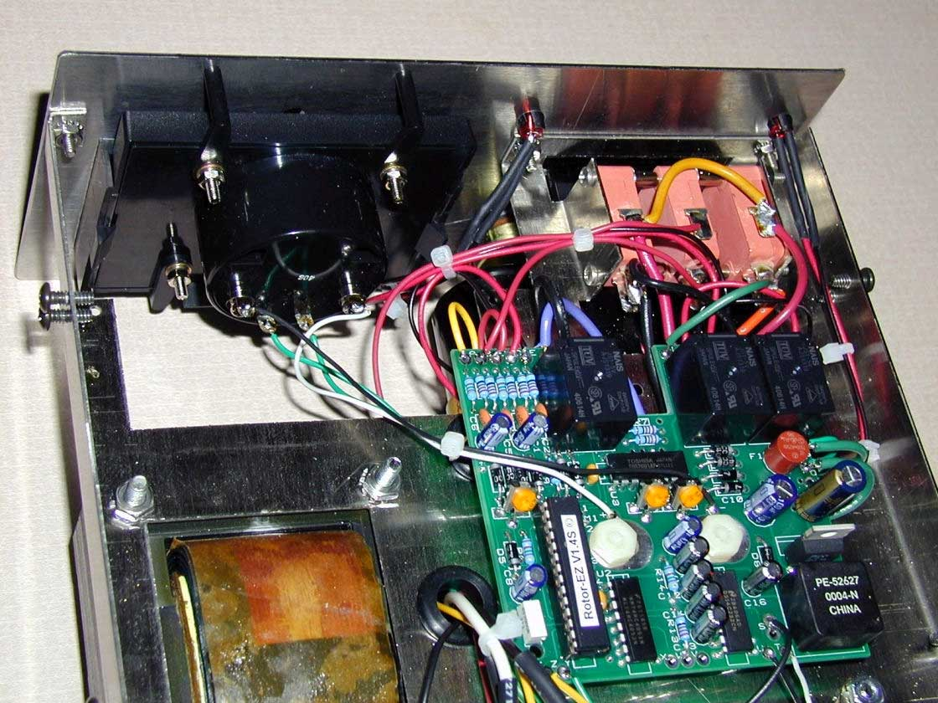

Figure 1. Rotor-EZ board installed on the underside of the control box.

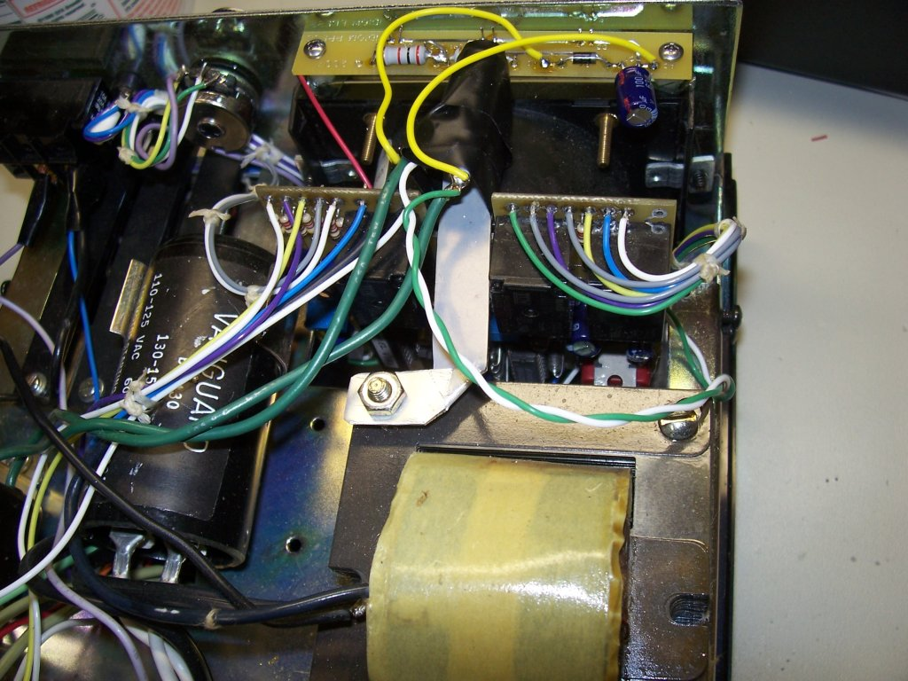

Figure 2. Rotor-EZ board installed behind the meter. Unfortunately it is difficult to see what is happening here. The Rotor-EZ board is mounted vertically, underneath the metal bar, with many wires going to it. The board with the yellow wires going to it at the top of the picture is the Ham Supply Rotator Illuminator LED light kit sitting on top of the black meter.

If these pictures are difficult to see in the black and white printed copy, then it may help to download the manual http://www.hamsupply.com/support/ .Then you can see the pictures in color on your computer screen.

There are two types of circuit boards other than Rotor-EZ boards that are commonly found inside control boxes. One type is a brake delay board, which has either a large square delay module with many terminals on it or some relays. The second type of circuit board is used to drive the meter, and also the LEDs if the control box has LEDs. The Rotor-EZ board does all these functions, and so the other circuit boards will not be required.

Desolder and disconnect all wires going to circuit boards, apart from the following exceptions. Leave the wire attached to the circuit board and disconnect the other end.
Exceptions:
For any wires connected to the smaller “instrument” transformer, leave the wires connected to the transformer and unsolder the other end from the circuit board.
If you decided to mount the Rotor-EZ board on the underside of the control box, then leave the two wires attached to the meter, if there are wires there, and desolder them from the circuit board.
If your control box already has LEDs installed, then it is probably easiest to use the existing LEDs and the wires connected to them. If that is what you decide to do then desolder the wires from the circuit boards.

Remove the circuit boards from the control box. You will not need them again.

If there are any discrete parts (parts not on a circuit board) attached to the meter, then remove them.

If there was a brake delay board mounted on the underside of the control box, then remove the standoffs that held the brake delay board. Secure each instrument transformer mounting screw with the 6-32 stainless steel nut provided with the Rotor-EZ, and the existing lock washer.

Completely remove all wires from the front panel “calibrate” potentiometer. If a switch is mounted behind the potentiometer, in which case the potentiometer will have six terminals rather than three, then remove those wires also.

Completely remove all wires from the rear panel “calibrate” switch if it exists.

Remove all wires going to terminals 3 and 7 on the rear terminal strip or Cinch plug.

If the Rotor-EZ board will be mounted on the meter studs:

Remove the metal bar holding the meter lamp. The metal bar will be replaced later, so do not lose it.

Try fitting the circuit over the meter terminals. The rectangular notch in the circuit board goes to the top, and the white component layout markings face the rear.

Early rotor control units had large 1/4” meter mounting studs. If your meter has the large studs, use a round file to carefully enlarge the meter holes in the circuit board enough to fit the circuit board over the meter studs, or consider mounting the Rotor-EZ board on the underside of the control box instead. Do not enlarge the holes unless necessary. (Please note that it was impossible to make the circuit board meter stud holes universal; if the hole was made bigger to start, the holes become too large to mount the board on later series meters. Five different meters were used over the years, each with different studs and spacing.)

If the Rotor-EZ board will be mounted on the underside of the control box:

Find a place to drill two holes approximately 1.1” (28 mm) apart on the underside of the control box. Measure the bare circuit board to discover what the exact spacing of the screws should be. Two nylon screws will be installed in these holes, and the Rotor-EZ board will be mounted on the nylon screws. Be sure to choose places for the holes where the drill bit will not strike anything on the other side of the chassis.
If there had been a brake delay board mounted on the underside of the control box, then we recommend that you use the hole that held the standoff closest to the center of the chassis. That hole will need to be enlarged. The other hole can be 1.1” (28 mm) towards the small “instrument” transformer.

If there was no brake delay board mounted on the underside of the control box, then you must find the best place for the holes yourself. Use the Rotor-EZ board as a pattern to find the best location. Be very careful that there is nothing in the way on the other side of the chassis. Many wires will go from the Rotor-EZ board through the large hole to the other side of the chassis; find a location that will make the wires short and the installation easy.

When drilling a hole, be sure to use a center punch to make a dent first, so that the drill bit does not wander. Then drill a small “pilot” hole using a small drill bit. Finally use the larger drill bit to make the hole the correct size. After drilling the hole, be sure that the hole has no burrs (small sharp pieces of metal). Also be sure to remove the metal bits that fall from the drill inside the box.

Mark the location of the two holes. Check again that there is nothing on the other side where you will drill. Drill the two holes with a 3/16” (4.8 mm) drill bit.

Insert two 3/4” (19 mm) long nylon screws into the holes from the top of the chassis, so that they point down towards the underside of the control box. Secure them with two nylon nuts. Do not over-tighten the nuts.

Screw a second nylon nut part of the way down each nylon screw, leaving about 3/16” (5 mm) of thread exposed. The Rotor-EZ board will rest on these nuts.

Put the empty Rotor-EZ board on the nylon nuts to see if it fits.

There are several software options that can be disabled by using jumpers on the PC Board. They are more completely described in the operating manual. If you want to change any options, you must solder jumpers to the board. The options are:

Preset Electronic End Points – recommended for all users. Prevents the system from slamming into the end stops by removing power from the motor 5 degrees before the end point is reached. This option may be disabled by soldering a jumper wire between pin 22 of U1 and ground hole S-4 next to the pin.

Overshoot Protection – removes power from the rotator motor 3 degrees before the desired bearing is reached, allowing the antenna system to “coast”. This option may be disabled by soldering a jumper wire between pin 23 of U-1 and the ground hole S-3 next to the pin.

Unstick Routine – TailTwister rotors in particular often encounter brake jams, where the brake cannot release because of lateral pressure. Rotor-EZ includes an effective automatic brake unstick routine. This routine may be disabled by grounding pin 27 of U1 to the ground hole just to the right of it.

90° Offset Support – This option turns the meter needle 90° right or left of the normal bearing, to support antennas at right angles to the main antenna, as explained in the operating manual. Grounding pin 28 of U-1 puts the control in offset mode. If you want to use the offset mode you will need to switch it in and out. The direction of the offset, plus or minus, is determined by pin 24. If pin 24 is not grounded, the offset is +90°. If pin 24 is grounded, the offset is -90°. There is no grounding pad next to pin 24, but you can use the ground pad for any otherwise unused option or use pin 1 of U2. If you have no present plan to use this feature, do nothing to pins 24 and 28 of U1.

 | Pin 28 grounded | Pin 28 not grounded
Pin 24 grounded | -90º | no offset
Pin 24 not grounded | +90º | no offset

Solder jumper wires as needed to disable unwanted options, and to determine the offset direction. The jumper wires can be small pieces of solid thin copper wire, or scrap component leads. Check any solder connections you make with a bright light and a magnifying glass to verify that the solder joint is good, and that there are no accidental solder bridges.

Rotor-EZ uses four different LEDs to report the operating status of the unit. Early control boxes have no existing holes. Some later control boxes have three LEDs already mounted. Other control boxes may have three holes already drilled in the secondary front panel, even though the primary panel does not have them. In any case, you will need four holes. Put the control back in its case. This makes hole drilling easier. Drill through the front panel to open existing holes if there. In the following instructions, drill bit sizes in inches are given. If you have metric-sized drill bits, then it will be necessary to experiment to find the best size drill bit to use; the inch size is converted to millimeters in parentheses to help determine the correct size.

When drilling a hole, be sure to use a center punch to make a dent first, so that the drill bit does not wander. Then drill a small pilot hole using a 3/32” (2.4 mm) drill bit. Use the larger drill bit last. After drilling the hole, be sure that the hole has no burrs (small sharp pieces of metal). Also be sure to remove the metal bits that fall from the drill inside the box.

If there is not a “clockwise” LED mounted already, drill a 1/4” (6.35 mm) hole for the “clockwise” LED in the center of the clockwise arrow on the front panel.

If there is not a “counter-clockwise” LED mounted already, drill a 1/4” (6.35 mm) hole for the “counter-clockwise” LED in the center of the counter-clockwise arrow on the front panel.

If there is not a “brake release” LED mounted already, drill a 1/4” (6.35 mm) hole approximately 1/4” (6 mm) above where it says "BRAKE RELEASE" on the front panel.

Drill a 1/4” (6.35 mm) hole for the “status” LED approximately 3/4” (19 mm) above where it says "BRAKE RELEASE" on the front panel, which should be approximately 1/2” (13 mm) above the “brake release” LED.

If your kit has the RS-232 option, you will need a 5/16” (8 mm) hole on the rear panel. You may find a suitable hole already punched, perhaps with a plastic plug. If not, then find a good location for the hole well clear of the power cord, and drill the hole. Be sure to center punch first and use a pilot hole. After drilling, clean the hole and insert the rubber grommet supplied.

Notes on wire: two gauges of hook-up wire supplied, #18 and #24, for board installation. Use #24 gauge (the thinner wire) except where the instruction specifically calls for #18 gauge (the thicker wire). Multiple colors are provided to make identification easier. Select different colors that make sense to you. Write down the color of each wire used in this manual to make later identification easier.

If you are using the clockwise, counter-clockwise and brake release LEDs that are already installed in the front panel of the control box, then wire those LEDs to the board, using the diagram on the next page as a guide. For each LED mounted in the front panel, remove the LED that is already connected to the board. Make sure that the wires are long enough to reach the board when the board is installed; use splices if the wires are not long enough. (If you do splice wires together, then insulate the splices with heat-shrink insulation or electrical tape.) If you can’t see which lead is for the cathode and which is for the anode, then just solder the wires without worrying about the polarity. Later you will test the LEDs, and you can reverse the leads for LEDs that don’t work.

If you are using the LEDs that are already wired to the Rotor-EZ board, then check to see that the wires will be long enough to reach their places in the front panel when the Rotor-EZ board is mounted in its final location. If the wires are not long enough, then splice more wire to make them longer, or replace the existing wires with longer wires. The diagram on the next page will help to identify which LED is which. DO NOT INSTALL THE LEDs into the front panel yet.

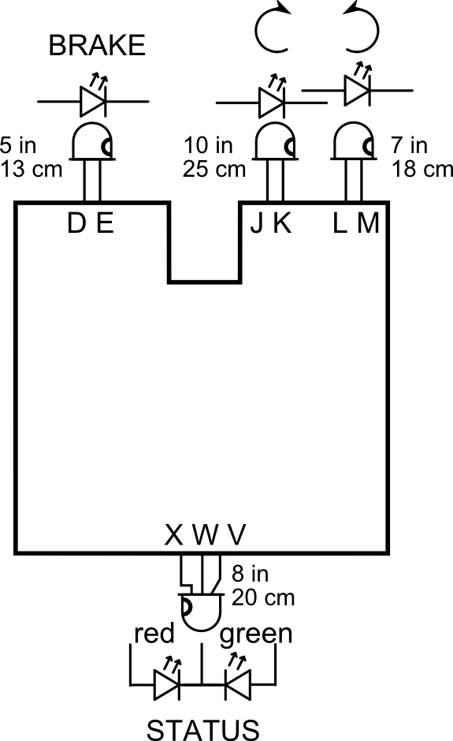

In this LED connection diagram, the notch on one side of the LED symbol represents the cathode, which is marked by a flat side on the flange. The suggested wire lengths are only correct if the Rotor-EZ board is being installed behind the meter.

Many of the following instructions give suggested lengths for the wires. These suggested lengths are only for Rotor-EZ boards that are mounted behind the meter. If you are installing your Rotor-EZ board on the underside of the control box, then you must choose the length of the wires yourself. Unfortunately, it is not possible to give the lengths of wire for Rotor-EZ boards installed on the underside of the chassis, because there are many possible locations to put the Rotor-EZ board.

If you are installing the board on the underside of the chassis, then mount the board on the nylon screws, and use the last two nylon nuts to hold the board in place.

If you are installing the board behind the meter, then do not install the board yet. That will be done later.

Install a 6” (15 cm) wire from hole "P" to the lamp body terminal (Note that the wires from the smaller transformer are to remain attached to the lamp socket).

Install a 6” (15 cm) wire from hole "Q" to the lamp center terminal. Important: Note that hole “R” is not used.

Terminal #1 on the rear has a wire going to a chassis ground solder terminal. Install an 11” (28 cm) wire from hole “S” to that grounded solder terminal. Do not remove the original wire from the terminal.

Install a 5” (13 cm) wire from the hole marked “+5" to the most clockwise terminal of the three terminals of the calibration potentiometer as viewed from the front of the unit. Be sure you get this wire and the next two wires below on the correct terminals of the potentiometer and the correct holes on the board or you may blow the fuse when you power the unit. If there is a switch mounted on the rear of the potentiometer, do not use the switch terminals at this time.

Install a 5” (13 cm) wire from hole "Z" to center terminal of the calibration potentiometer.

Install a 5” (13 cm) wire from hole "Y" to the most counter-clockwise terminal of the calibration potentiometer.

Pretest

If you want to install the board behind the meter then screw the board onto the terminals using the nuts that are there, with the circuit board notch facing up and components facing away from the meter.

If you are mounting the board on the underside of the chassis, then use a wire to connect the meter’s positive lead to the “M+” terminal on the board. If your meter has brass studs then tin the end of the wire with solder and use the nut to hold the end of the wire down. In the same way, connect the meter’s negative lead to the “M-” terminal on the board. There should be no other wires connected to the meter.

Make sure that no wires are loose or accidentally grounded. Plug the control box in. When power is first applied the meter should go to full scale for a second or two. The meter would then normally display the antenna position; however, since the rotator is not connected the microprocessor will sense an open circuit. The microprocessor announces this by wiggling the meter needle. Rotate the Bearing Set knob on the front panel (formerly the calibration knob) clockwise and verify that the meter moves from left to right. If the meter moves the wrong direction then the “+5” and “Y” wires going to the potentiometer must be reversed. If nothing happens, do not proceed until the problem is resolved. When finished, unplug the control box from the wall before working on it again. All further assembly will be done with the card mounted in the control box.

IMPORTANT NOTE: many wires added will be attached to points in the rotator control box that already have one or more wires soldered to them. Unless otherwise instructed, do not remove any existing wires – rather, solder the new wire over the existing wire or wires. Remember that the wire lengths in the next steps only apply if the Rotor-EZ board is mounted behind the meter; if the Rotor-EZ board is mounted on the underside of the chassis, then you must measure the wire yourself.

If there is any confusion about how the wires are connected, the best reference is the Interconnection Diagram on page 13 of this manual.

Install an 8” (20 cm) wire from hole "A" on the circuit board to the rear terminal strip contact "7"
Install an 8” (20 cm) wire from hole "C" to terminal strip contact "3"
Install an 11” (28 cm) #18 wire from hole "O" to terminal strip contact "2"
Install an 11” (28 cm) #18 wire from hole "I" to terminal strip contact "5"
Install an 11” (28 cm) #18 wire from hole "N" to terminal strip contact "6"

The main power switch has a wire connected to the BRAKE switch. Remove the end of that wire from the power switch, and solder it to the most clockwise terminal of the calibration potentiometer, over the wire going to “+5”.

Remove the "power transformer input wire" connected to the other side of the BRAKE switch and reconnect that wire to hole "G" on the circuit board.

Using a 7” (18 cm) #18 wire, connect hole "F" on the circuit board to the switched side of the main power switch. For identification purposes, note that this switch terminal will also have a wire running to the smaller transformer.

Connect a 10” (25 cm) wire from hole "B" on the circuit board to the BRAKE switch terminal from which you removed the power transformer wire earlier. (Note: the switch may have a terminal that was not used before. If so, it is not used now either!)

Following the above modifications to the Brake Switch, confirm that the brake switch is wired correctly as follows, or damage to the unit may result: One side of the Brake switch is wired to hole "B" on the circuit board. The other side of the switch is connected to 5 volts, coming from the front mounted calibration potentiometer. All other existing wires on the brake switch have been removed. (Relay K3, when activated, now connects "switched main power" wire "F" to the input of the power transformer wire "G".)

If you have the RS-232 option, carefully strip the outer insulation and remove the foil shield from about 2” (5 cm) of the cut end of the molded serial cable. You will need to make connections using three of the inner wires according to the following table. Unfortunately the wire colors often vary, so you must verify that the colors are correct for your cable. Strip the insulation from about 0.25” (6 mm) of the end of all the insulated inner wires. Tin the ends. Using a multimeter, verify that the continuity according to the table is correct: in other words, test the wire connected to pin 2, wire to pin 3, and wire to pin 5. Mark the colors below.

Pin # | Function | Wire Color | Pad
2 | RX |  | T
3 | TX |  | U
5 | GND |  | solder terminal (ground)

If you have the RS-232 option, mount the supplied solder terminal under the transformer nut closest to the Rotor-EZ board on the bottom of the unit. Insert the rubber grommet into the hole in the chassis that the serial cable will go through. Pass the molded serial cable through the rubber grommet to the solder terminal. Solder the wire connected to RS-232 pin 5 to the solder terminal. Solder the wire from pin 3 to hole "U" of the PC board. Solder the wire from pin 2 to hole "T" of the PC board.

Inspect work for solder bridges and wiring errors. Verify that there are no loose wires. Confirm that no wire goes to hole “R”. If you removed the bar holding the meter lamp, now replace it and tighten the nut, and position the lamp and lamp socket.

Mount the LEDs in the appropriate panel holes using the plastic LED holders. The bicolor LED with three terminals goes in the top center hole. Plug the unit in and turn on to confirm that the meter lamp lights. Unplug the control box and re-attach the rotator control wires. Plug the unit in and turn on. The unit should function in the normal manual mode as before, except that the brake will not engage for five seconds after any other operation is completed. The rotational LEDs do not light in manual operation. The operating manual describes the use and features available.

If you added a wire to the circuit board for the 90° offset feature, bring that wire to the switch mounted on the rear of the original calibrate potentiometer if there is one. Use an ohmmeter to determine which terminal is switched, and solder the wire there. Solder another wire from the common terminal of the switch to ground. Thus, when the switch is actuated, the wire is grounded, enabling the option. Test the circuit with an ohmmeter to see that the activating wire from the circuit board grounds when switched, and ungrounded when switched back! You can also add an RCA connector or the like to the back of the control box, and run a wire paralleling the switched wire so that the wire may be grounded externally. The connector should be bypassed to ground with a 0.1 μF capacitor. Before beginning calibration, make sure the 90° offset wire is ungrounded!

BASIC FUNCTION TEST

Plug the control box into mains power.

Test the manual operation of the control box by using the clockwise button and the brake release button to turn the rotator clockwise. Verify that the rotator turns clockwise, and that the meter moves in the correct direction (left to right). The clockwise and counter-clockwise LEDs will not light during manual operation. The Rotor-EZ should automatically delay setting the brake for several seconds after you stop pressing the brake release button. If the meter moves the wrong direction then wires "A" and "C" need to be reversed. (If you find it necessary to correct any mistakes, be sure to unplug the control box from mains power first.)

Use the counter-clockwise button and the brake release button to verify that the rotator also turns counter-clockwise normally under manual control.

Test the bearing set feature of the Rotor-EZ by turning the front panel set potentiometer (the front panel knob that says “Calibrate”) to point the needle to a different bearing, and then momentarily pressing the brake release button. You must press the brake release button within a few seconds of turning the knob; if you wait too long, the Rotor-EZ will “time out” and return the meter needle to the current bearing. The Rotor-EZ should turn the rotator to the bearing you selected, pause for several seconds, and set the brake. Test this feature at least once in each direction to verify that the Rotor-EZ can command the rotator to turn both clockwise and counter-clockwise. If the unstick routine is enabled, then the rotator should momentarily turn in the opposite direction before proceeding in the direction of the target bearing.

Use the bearing set feature again to have the Rotor-EZ board turn the rotator. Be sure to use the bearing set feature with the “calibrate” knob and the brake release button, and not by controlling the rotator manually with the clockwise and counter-clockwise lever-style buttons on the front panel. While the rotator is turning, verify that all four LEDs work correctly. The clockwise and counter-clockwise LEDs will light when the Rotor-EZ board is commanding the rotator to turn; the clockwise and counter-clockwise LEDs do not light when the rotator is being controlled manually. The brake LED will light when the brake is off, and go out when the brake is set. The bicolor LED will appear red when the rotator is beginning its journey, yellow in the middle of the journey, and green at the end of the journey. If an LED refuses to light, then try reversing its wires where they connect to the Rotor-EZ board; the most common problem is incorrect polarity.

If any of the basic function tests fail, then fix the problem before proceeding. The Troubleshooting section of the manual and the Voltage Test Chart may be helpful.

CALIBRATION

Rotate the front panel set potentiometer fully counter-clockwise. Now, using a jeweler’s screwdriver, adjust the “zero” meter setting using the mechanical adjustment behind the hole beneath the center of the meter to set the needle for 180 degrees. Note: after 5 seconds the meter pointer will return to its prior reading. Should you need more time, turn the set potentiometer back a few degrees, then back to the fully counter-clockwise position and try again.

When performing the following steps, be careful the screwdriver shaft does not short out anything. If necessary, put tape over the screwdriver shaft to temporarily insulate it. Preset potentiometers R16 and R17 by turning them full counter-clockwise when viewing the front side of the potentiometers. It is usually necessary to tip the rotator control up considerably so that access to the potentiometers can be reached from the bottom. The front side body of potentiometers R 15, 16 and 17 is usually blue in color and is molded to accept either a straight or Phillips screwdriver.

Note that if the rotator potentiometer strip and the rotator-control electronics are closely matched, calibration potentiometers R16 and R17 on the Rotor-EZ board may need little or no further adjustment in the following steps.

Also, the following steps typically require that the front of the control be lifted up to offer access to the calibration potentiometers. After each adjustment, set the control back down flat to see that the meter reading is correct when the unit is sitting flat.

Rotate the front panel mounted set potentiometer fully clockwise. Adjust R15 so that the meter needle lines up on the clockwise 180° line. Reset the needle if the five-second timeout occurs.

NOTE - The following two steps have caused confusion for some builders. For this reason some further information is included here. Calibration potentiometers R16 and R17 are read by the processor and are used to calibrate the system using mathematics in software, not by using classical analog methods. The result of this is that when the calibration potentiometer is turned further clockwise than necessary no visible effect will be seen on the meter. It is important that both potentiometers are set to the most clockwise position needed for calibration but no further that results in a visible effect on the meter. This is often the most counter-clockwise setting for the potentiometer. In order to see the effect of the calibration potentiometers, the paddles can be used to select a rotator position 5-10 degrees north of the CCW south. Now when R16 is manipulated the effect will be visible and you can see the potentiometer subtract out the 5-10 degrees of error that you deliberately introduced.

Using the manual paddles, rotate the antenna full counterclockwise. Do not rely on the meter for this as it is not yet calibrated. Now, turn potentiometer R16 clockwise until the meter needle has gone as far left as it will go. STOP at that point – Do NOT turn the potentiometer further - once the calibration calculation reaches its mathematical limit, further potentiometer rotation will cause miss-calibration even though the meter appears correct.

Using the manual paddles, rotate the antenna fully clockwise. Again, do not rely on the meter for this as the meter is not yet calibrated. Once the antenna is fully clockwise, see if the meter needle is reading 180°. If not, turn R17 clockwise until the needle reaches the clockwise 180° mark. Do NOT go further – further clockwise potentiometer rotation will result in a miss-calibration for other directions even though the meter appears correct, due to physical limits of the meter movement.

This completes assembly and calibration of your unit. Use the supplied cable ties to dress up the wires in the rotator control box before replacing the covers. Then, read the operating manual so you will fully understand Rotor-EZ’s capabilities.

Comments about this document are welcome, especially from customers whose first language is not English. Please email your comments to contact@hamsupply.com.

PARTS LAYOUT DIAGRAM

This parts layout diagram matches the most recent revision of the circuit board. Other versions of the circuit board have minor differences. In some circuit board revisions, the positions of D1 and D6 are reversed.

Please note that in one version of the circuit board, the silkscreen shows an incorrect polarity for D9, D10, D11, and D12. The polarity of D9 – D12 is correct in this diagram for all revisions of the circuit board.
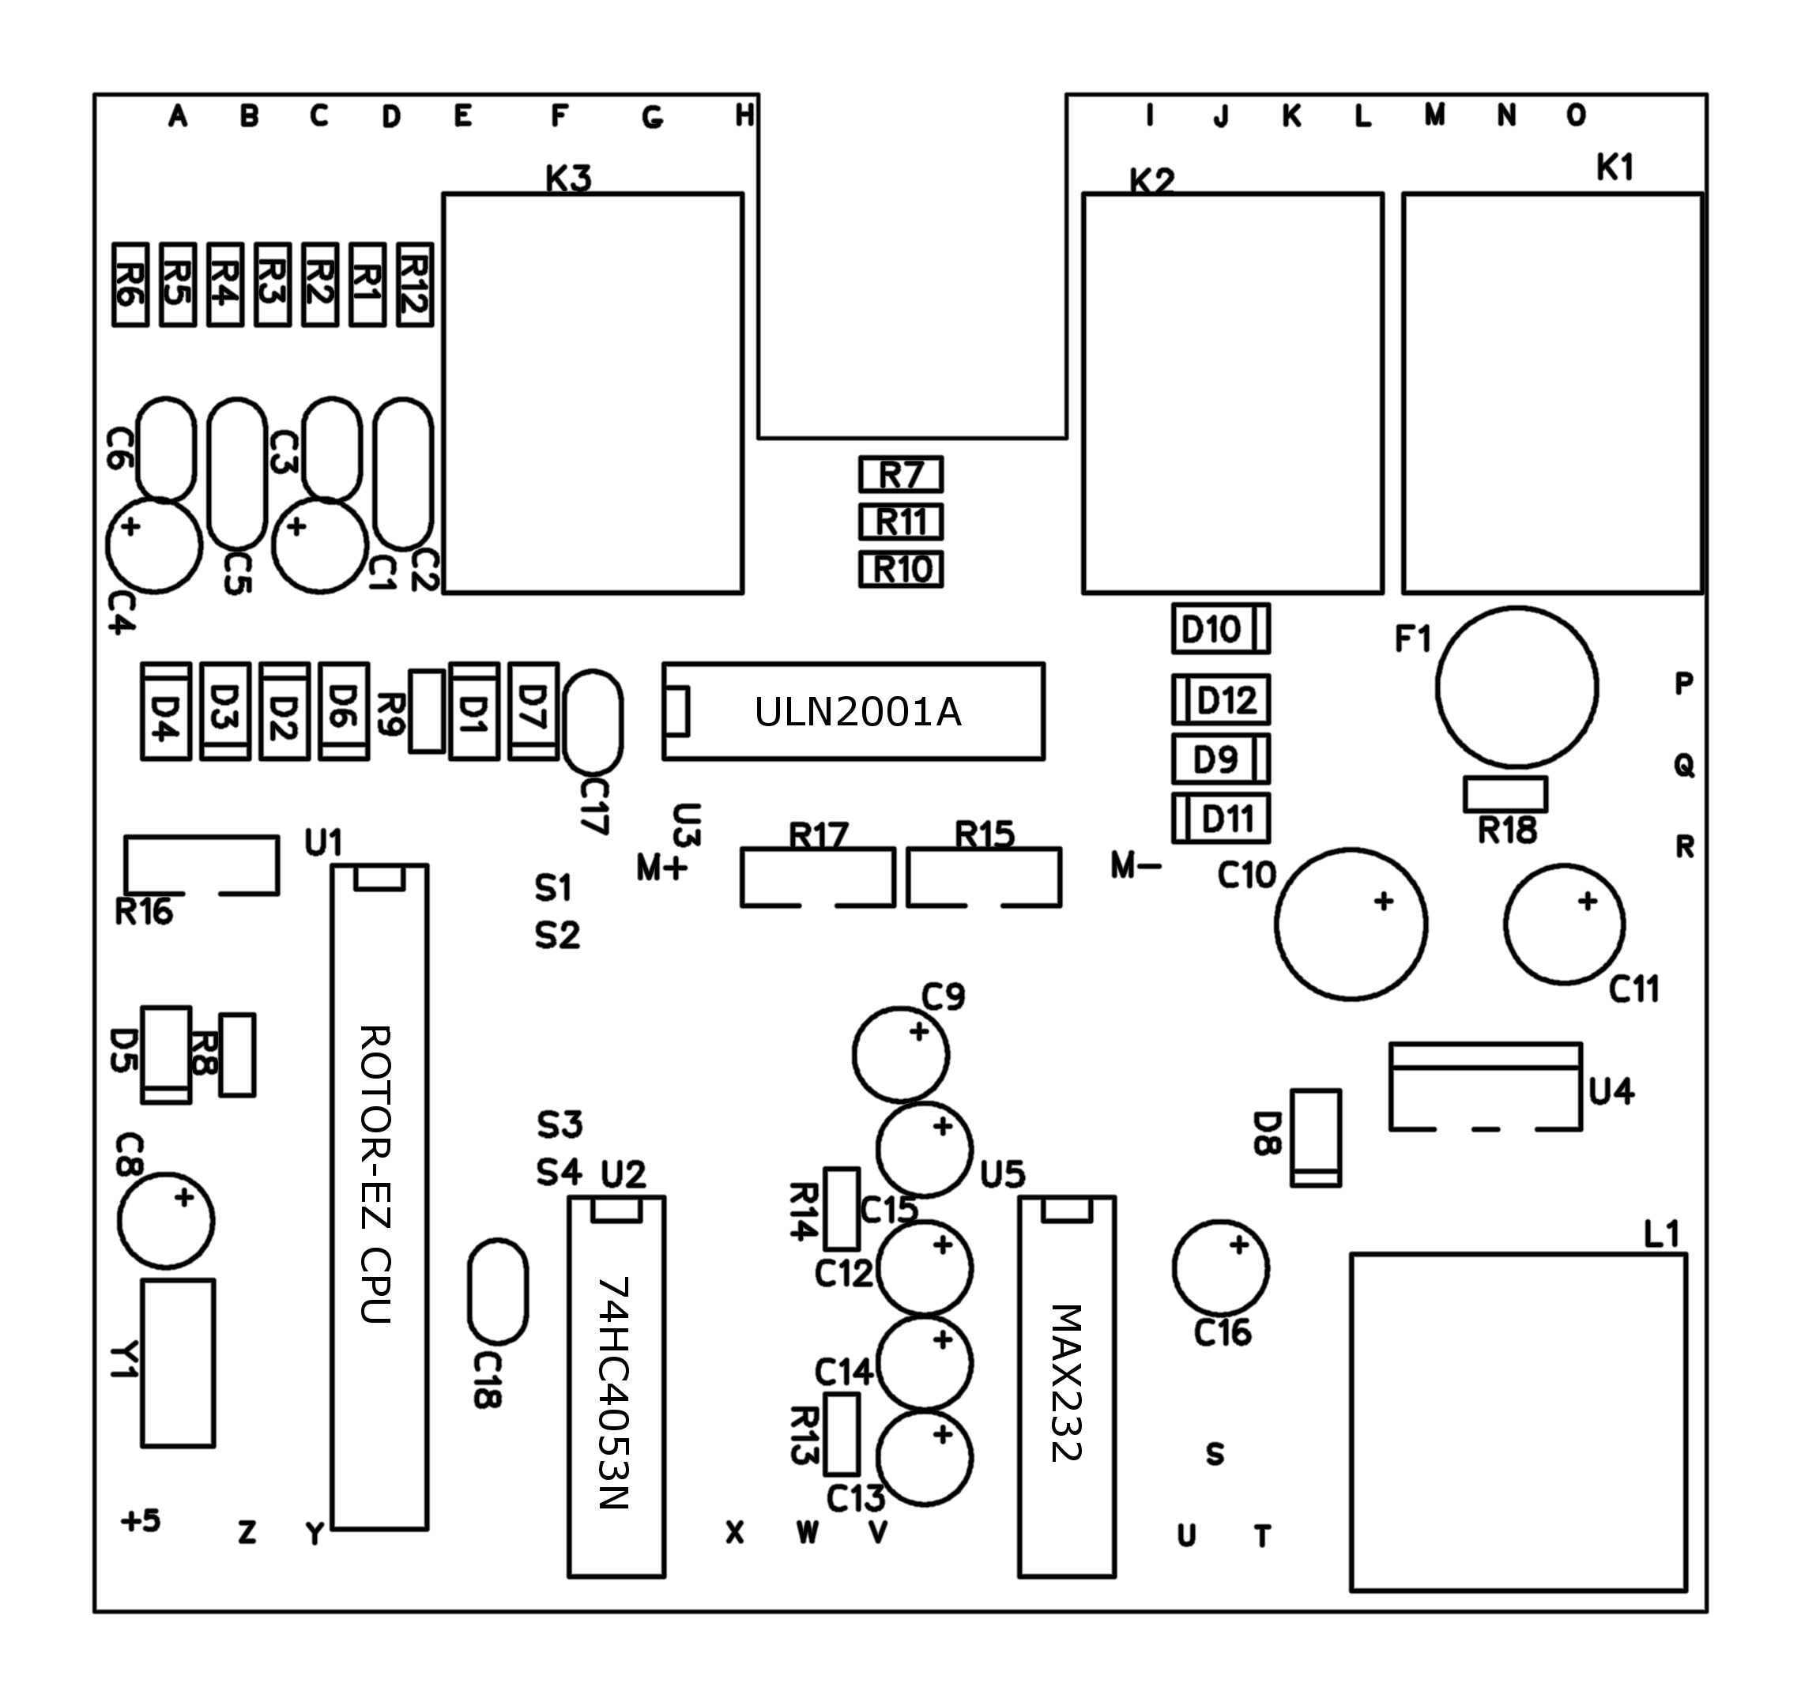

Schematic Diagram

+5

+5

+5

+5

+5

+5

+5

+5

+5

+5

+5

+5

+5

+5

+5

+5

+5

+5

(BRK RLY) Power Xform.

AC

LAMP
-
1

5k

Not on

(CW, CCW)
Term 2

(CCW)

Term 6
ROTOR

POSITO
N

SENSOR

PC Board

(CW) Term
5

GRN

Mount

Not on

(BRK
LED)

YEL

(BRK RLY) Power Switch

Panel

AC

LAMP
-
2

PC board

(CW LED)

(CCW
LED)

RS232 RX

RS232 TX

Term 3

Term 7

RS232
GND

CHASSIS

GND

SPARE
GND

(BRK SW

SENSE)

[1]

[1]

[1]

[1]

[
1]

[1]

[1]

[1]

Note [1] : Only populated with RS232
Option

Note [2] : RS232 OPTION REQ. U1 VERSION
REZ
-
S

[2]

Note [3] : ALL DIODES 1N4007 UNLESS OTHERWISE
MARKED

METER
GAIN

ANT

ZERO

ANT

GAIN

TERM 1

E

H

W

G

F

V

R12

220

P

C

A

O

R9

220

N

K

I

F1

FUSE

R6

4.7k

K3

B

C15

1μF

+

T

U

U5

MAX232

C1+

1

C1
-

3

C2+

4

C2
-

5

L1
-
IN

13

L2
-
IN

8

L1
-
OUT

14

L2
-
OUT

7

+10

2

-
10

6

D1
-
OUT

12

D2
-
OUT

9

D1
-
IN

11

D2
-
IN

10

C14

1μF

+

D12

D9

D5

D10

D11

-

C8

4
.7μF

+

R3

4.7k

D7

R13

220

L

R1

220

R2

220

R16

500

J

D2

L1

330uh

Q

Z

+

C9

4.7μF

+

M2

1ma

K1

M

R10

220

R14

4.7k

U1

PIC16C73_A

VPP

1

AN0

2

AN2

4

AN3

5

RA4

6

RA5

7

VSS

8

RB0

21

RB1

22

RB2

23

RB3

24

RB4

2
5

RB5

26

RB6

27

RB7

28

AN1

3

OSC1

9

OSC2

10

RC0

11

CCP2

12

CCP1

13

RC3

14

RC4

15

RC5

16

TX

17

RX

18

VSS

19

VDD

20

X

D1

R4

220

C5

.01

S

C16

.1μF

+

D6

D

+5

C12

1μF

+

D3

R5

220

R17

500

K2

U3

TD62001

B1

1

B2

2

B3

3

B4

4

B5

5

B6

6

B7

7

G

8

D

9

C7

10

C6

11

C5

12

C4

13

C3

14

C2

15

C1

16

R11

220

U2

4053

X0

12

X1

13

Y0

2

Y1

1

Z0

5

Z1

3

INH

6

A

11

B

10

C

9

X

14

Y

15

Z

4

C13

1μF

+

C10

100μF

+

C1

4.7μF

+

C17

.1μF

+

Y1

XTAL

S1

Y

S3
-
OS

S2
-
US

S

R15

500

S4
-
EP

U4

LM2575

IN

1

OUT

2

FB

4

GN
D

3

ON
F

5

C18

.1μF

+

D8

11DQ06

C11

330μF

+

C6

.001

C2

.01

C4

4.7μF

+

C3

.001

D4

R8

4.7k

Schematic © Ham Supply
Interconnection Diagram

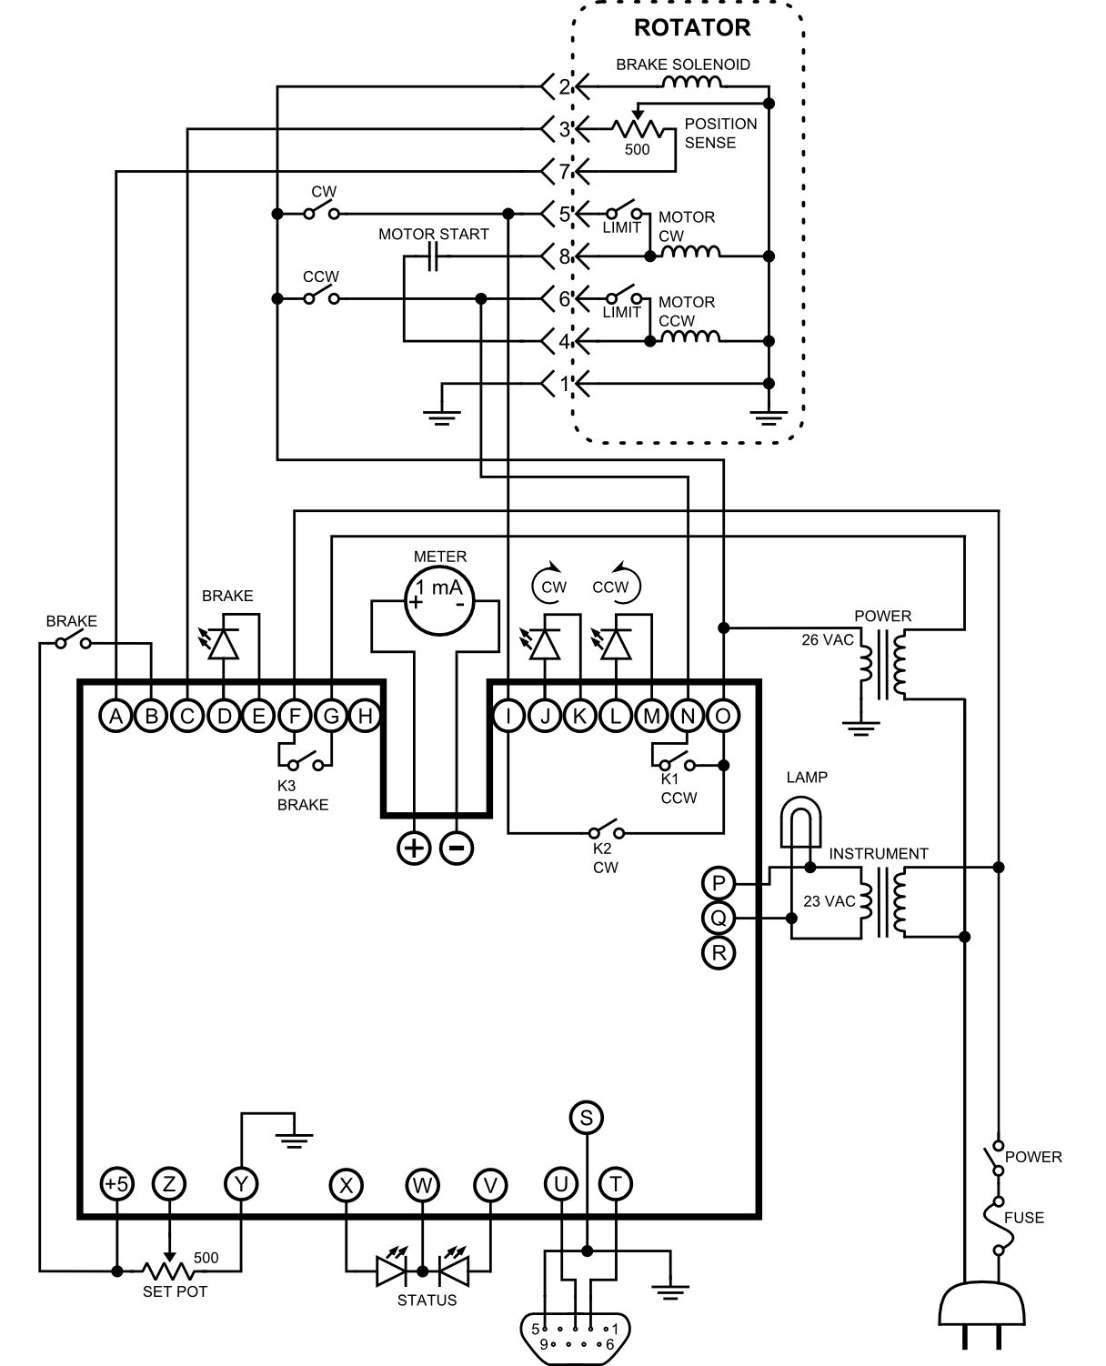

Rotor-EZ Theory of operation

The Rotor-EZ circuit is made up of the following modules:

- Power supply
- Fuse
- Microprocessor
- Pulse Width Modulators (PWM’s)
- Analog inputs
- Digital Inputs
- Relays
- RS-232 Interface
- Software

- Power supply: Since only voltages unsuitable for a linear regulator are available inside the control box, a switching power supply was designed. A simple circuit suffices, due to the low current requirements. U4, D8, L1, C10 and C11 constitute the entire switching power supply design. D9 through D12 act as a full bridge rectifier converting the AC input from the pilot lamp socket to DC necessary for the switching supply. Capacitors C16 – C18 offer decoupling.

- Fuse: The power supply is protected by a fuse F1, which is either a small brown cylinder marked “T500mA250V”, or a tan device that looks very much like a disc capacitor that is marked “60 050” in very small letters. The brown cylinder type fuse is a traditional type of fuse that must be replaced if the fuse blows; replacement fuses are available from Ham Supply. The tan fuse that looks like a disc capacitor is a PPTC (polymeric positive temperature coefficient) resettable fuse.

If your Rotor-EZ is equipped with a PPTC-type resettable fuse, and too much current passes through the fuse because of a short circuit problem, then the fuse will heat internally and the resistance of the fuse will become very high, which will interrupt the current to the on-board 5 VDC power supply. Of course the power should be disconnected if this happens. Once the power is disconnected and the fault is fixed, the fuse will cool in a few minutes, and then the fuse will work again.

- Microprocessor: The microprocessor U1 is a Microchip PIC16C73B. A resonator Y1 offers the precision time reference required for serial communication. The Microprocessor contains ROM instruction memory, which is programmed with the control algorithms, serial communication, analog to digital conversion, state machines and lookup tables needed.

- Pulse Width Modulators: The microprocessor also contains two Pulse Width Modulators. The PWMs control the meter movement and the bi-color LED. An analog MUX, U2, is controlled by the PWMs and provides a precision 0.0 VDC or 5.0 VDC to the bi-color LED or to the meter movement’s low pass filter. The meter movement uses a simple low pass filter C9 and R14 to change the duty cycle of the PWM into a current source for the 1 mA full-scale analog meter. R15 is used to calibrate the full scale deflection of the meter.

- Analog inputs: Analog inputs determine the resistance of the antenna potentiometer. A bridge network R1 –R5 conditions the antenna potentiometer sense circuit. Clamping diodes D1 – D4 and series resistance R3 and R6 protect the processor from erroneous inputs. The bridge network isolates the antenna potentiometer resistance measurement from changes in line impedance. Filtering C1 – C6 prevent 60 Hz noise and RF energy from affecting the antenna position sense. The Set Potentiometer sense is connected directly to the processor analog input and is not protected because the signal is internal to the controller.

- Digital inputs: The Brake Switch sense circuit uses R9, C8 and D5 as a half-wave rectifier. R8 is used to bleed off energy stored in C8 after the Brake Switch is released. R9, D6 and D7 are used to clamp the Brake Switch sense to valid levels and provide protection from erroneous inputs.

- Relays: U3 drives the relays and provides protection from the current surge resulting from the relay inductor field collapse. Relay K1 is in parallel with the front panel Counter-Clockwise switch. Relay K2 is in parallel with the front panel Clockwise switch. Relay K3 replaces the front panel Brake switch as the switch that controls power to the primary winding of the power transformer in the control box. (The Brake switch becomes an input to the microprocessor, and no longer switches power to the primary winding of the power transformer.)

- RS-232 Interface: U4 performs the signal conditioning necessary to interface with RS-232. This is done with charge pumps C12 – C15 that create low precision positive and negative voltage references which are RS-232 voltage level compliant.

- Software: The copyrighted software was developed in assembly language, and was written from the ground up specifically for this application.

Troubleshooting

If you are attempting to troubleshoot a board that you built or installed yourself, then the best first step is usually to double-check or triple-check your wiring for errors. Use a bright light and a magnifying glass to check for solder bridges or bad solder joints on the board. Verify that all parts are installed in the correct positions, and that the diodes, electrolytic capacitors, and integrated circuits are installed with the correct polarity. Inspection is usually the easiest way to find problems, so look at the board and the wiring from the board to the control box carefully before doing any other troubleshooting.

If the problem is not found by inspecting the board, then logic must be used to find the problem. The Rotor-EZ circuit can be divided into sections: the power supply section, the bearing sense section, the relay drive section, the LED drive section, the meter drive section, the serial control section, and the front-panel control section. The next task is to determine which section or sections don’t work. Some sections are easy to test: if +5 VDC is present on the board as shown in the schematic, then the power supply circuit probably works. If the meter needle sweeps across the entire scale when the control box is turned on, then the meter drive circuit probably works. If the needle is shaking continuously, that is the Rotor-EZ trying to alert the operator that there is a problem with the bearing sense circuit.

If the Rotor-EZ board does not work at all, then the next thing to check is the power supply circuit. If the control box meter lamp works, then the small transformer in the control box works and the Rotor-EZ board should be receiving approximately 23 VAC at terminals P and Q. The switching voltage regulator should be making +5 VDC, which can be measured in many places as marked on the schematic. If +5 VDC is missing, then the problem is most likely the fuse.

Your Rotor-EZ board will have either a traditional-type fuse that looks like a brown cylinder, or a tan PTC resettable-type fuse that looks like a disc capacitor. If too much current passes through a PTC resettable-type fuse, then it will heat internally and its resistance will become very high; once the problem is fixed and the PTC fuse is given several minutes to cool, then the fuse will work again. However, if the fuse is the brown cylinder traditional-type, then if it blows it must be replaced. The traditional-type fuse can be tested by removing it from the circuit and measuring its resistance; if the fuse is an open circuit, then it has failed. Replacement fuses can be purchased from Ham Supply.

Many inexperienced troubleshooters often blame the CPU for Rotor-EZ faults. It is true that the CPU is part of many of the sections of the Rotor-EZ circuit; it is also true that a defective CPU can explain many Rotor-EZ problems. However, the CPU is unlikely to be faulty in a new Rotor-EZ board, unless electrostatic discharge precautions have not been observed. The CPU is a relatively expensive part to replace, so our advice is to prove as much as possible that another component is not the problem before replacing the CPU. Please note that the CPU controls the front-panel meter, so if the meter needle sweeps across the entire scale when the control box is turned on, then the CPU probably works. Sometimes only part of the CPU is damaged, but this is uncommon.

If the Rotor-EZ board has +5 VDC, and the CPU is able to drive the front-panel meter, but the Rotor-EZ board can’t turn the rotator or release the brake, then the problem is most likely in the relay drive circuit. Trouble in the relay drive circuit is most easily found by tracing the signals as they pass from the CPU to U3 to the relays.

If there is a serial RS-232 communication problem, then all parts of the serial connection must be tested. The problem could be the computer software, the serial connection parameters, the serial port or USB adapter, the cable, or the Rotor-EZ board. One way to test the serial port and the cable is to try a “loopback” test. To do a loopback test, remove U5 the MAX232 serial interface IC from its socket, and connect pins 13 and 14 of the socket with a small piece of wire. Then use a general-purpose terminal program such as HyperTerminal to send some text. The text should be repeated immediately back to the terminal program. If the test is successful, then the serial port and the cable have been proven to work.

If a serial communications problem has been traced to the Rotor-EZ board, then the problem is most likely U5 the MAX232 serial interface IC, or U1 the CPU. The MAX232 IC seems to fail more often, and is less expensive, so it is best to try changing the MAX232 IC first.

If the Rotor-EZ CPU is sent an incorrect RS-232 command because of a software bug or because of noise on the line (RFI?) then the CPU may wait forever for the command to be completed. In this case the fix is to reset the CPU by switching the control box off and on again.

There is an article on the Ham Supply web site that describes how to troubleshoot serial communications problems in more detail. The article can be found here: http://www.hamsupply.com/support/

The Rotor-EZ board controls the front-panel meter. If the meter doesn’t work correctly, the problem can often be found by tracing the signal from the CPU. The signal goes from U1 pin 12 to U2 pin 10 as a square wave, and then comes out of U2 pin 15 as a square wave. (If you do not have an oscilloscope to see the square wave, you can detect whether the signal is present by using a multimeter on the AC volts setting.) R14, C9, and R15 convert the square wave into a current to be measured by the front panel meter.

The circuit that measures the bearing of the rotator is R1–R6, C1–C6, and D1–D4. If the CPU detects a problem in this circuit, it attempts to notify the operator by shaking the meter needle continuously. A problem in this circuit is most likely to be an incorrect component, a backwards diode or electrolytic capacitor, or a bad solder connection. Of course the problem could also be in the wiring between the Rotor-EZ board and the bearing sense potentiometer inside the rotator. Sometimes the problem is the bearing sense potentiometer itself; the easiest way to test this possibility is to plug the rotator into a different control box that is known to be good.

Relay K1 parallels the Counter-Clockwise front panel switch. Either the relay under the control of the microprocessor or the front panel switch under the control of the user can close the circuit to make the rotator turn counter-clockwise. Relay K2 parallels the front-panel Clockwise switch in a similar way.

Relay K3 replaces the brake switch as the switch that controls the power to the primary winding of the power transformer. The brake switch becomes only an input to the microprocessor. The control box now depends upon relay K3 to energize the power transformer. Whenever the power transformer is energized, the brake solenoid disengages the brake. The rotator also requires current from the power transformer to be able to turn the rotator.

If the Rotor-EZ board is unable to switch K3, then the control box will not be able to turn the rotator or release the brake, and there will be no voltage on control box output terminals 2, 4, 5, 6, or 8. If the Rotor-EZ board is not functional, then it is not possible to control the rotator, because the Rotor-EZ board operates the brake; in other words, there is no way to temporarily bypass the Rotor-EZ board to operate the rotator if the Rotor-EZ board is broken.

Rotor-EZ User Manual

The Rotor-EZ adaptation to the rotator control box offers the following operating modes:

Manual Mode: Here, use of the rotator is essentially the same as before. The paddles manually will move the antenna to whatever heading you desire. Always use one finger to depress the brake during manual operation, and another for the actual turning command. In Manual Mode, the only difference from a factory-original unit is that Rotor-EZ adds an automatic five-second brake delay. After rotation ceases and you release the paddles, the brake will not engage for another five seconds. This allows the antenna to stabilize first, and enhances the life of the rotator, the tower and the antenna.

Caution – when in manual mode, NEVER instantly reverse rotator direction if the rotator is fully under way – this can badly damage or destroy your rotator. Always allow the antenna to coast to a stop before reversing direction. Because you might need to free a frozen rotator or brake using manual control, Rotor-EZ does not prevent instantaneous reversals.

Auto-Point: What was the calibration knob becomes your pointing control. Turning the knob captures control of the direction meter needle, so you can "drive" the needle precisely to the desired bearing. (Note that when the knob captures the needle, the needle may start by moving to a different bearing than the actual bearing of the antenna. The needle is resynchronizing with the potentiometer. This is normal and nothing to worry about.) After you have moved the needle to the desired bearing, press and release the brake paddle, which starts rotation, and your hands are free! The meter needle returns to the actual antenna position and tracks the antenna as it moves. When the antenna reaches the new bearing, rotation stops, and after a 5 second delay the brake sets. LED's signal the motion, brake status, and how near the antenna is to the end of the rotation.

If you turn the pointer knob but do not execute the new heading by pressing the brake paddle briefly, after five seconds the command is abandoned, and the meter needle returns to the actual bearing.

Note that the top LED, which is the Status LED, changes color during an operation. Its steady state is green. Turning the pointer knob changes the LED color to red. Press the brake button to start rotation and the LED changes color to orange. Then, as the antenna moves to the new bearing, the LED color goes slowly from Orange to Green, giving you an indication of how close the antenna is to the final position. This is especially useful in case you have forgotten the bearing you commanded.

If the rotator will not turn at all as the result of a mechanical lock-up or an unusually recalcitrant brake jam after a new positioning command is given, after a few seconds the top LED will begin blinking to warn you that the command is not being executed. (See jam protection further down)

If the rotator control encounters a blank spot on the rotator potentiometer strip, the needle will wiggle, and the Status LED will blink, but rotation will continue for several seconds, usually enough to reach a good spot on the potentiometer strip, and continue rotating to the desired bearing.

The red brake LED, below the status LED, turns on whenever the brake is released. Whenever the brake is set, this LED is off. The two red LED's in the lower corners indicate the direction the antenna is turning. They do not turn on when the rotator is operating under manual control.

While the antenna is turning to a new bearing, you can change the set point provided it does not require the direction of rotation to reverse. If you try to turn the knob back in the opposite direction and pass the point where the antenna actually is, the rotation command is cancelled, and rotation stops immediately. In this case, the new bearing is held, and once the brake has released, pressing the brake paddle will start the antenna to the updated bearing. At any time during operation, rotation can be halted by simply pressing the brake paddle momentarily.

After a command is executed, but before the brake has set, a new rotation command can be given by pointing the knob, but note that the command cannot be executed until the brake has set. Once the red brake LED goes out, indicating that the brake is set, the brake paddle can be pressed again momentarily, which will start execution of the latest command.

New users of Rotor-EZ sometimes get confused in using the unit, almost invariably because they try to issue a new command before the old command has completed, i.e. before the brake has set. The solution is simple: wait for the brake LED to go out, then start over. If things get hopelessly confused, you can start all over by simply turning the rotator control box off and back on, completely resetting the system. Be sure, however, never to do this while the antenna is actually turning, because the brake slams home and at the least gives a considerable shock to antenna, tower and rotator.

Rotor-EZ includes selectable options. Each option is active unless the builder overrides them while assembling the printed circuit board. They are:

Unstick routine: If the Unstick option is enabled, when command execution begins, the rotator first pulses in the opposite direction for 1 second in case the brake is stuck, pauses 1 second, then turns in the proper direction. Experienced owners of TailTwister rotators understand this problem. In really cold weather this routine may not be enough to unjam a brake, though it usually will. In such cases, it may be necessary to rock the rotator back and forth multiple times, manually using the rotator control paddles, as you have done in past. Ham-M rotators are not as susceptible to this problem as are TailTwisters, and Ham-M owners may elect to disable this option as described in the construction manual.

Electronic End Point option: this option limits the rotation range to exclude the last 5 degrees at each end of the meter scale, preventing the rotator from jamming on the end stop. TailTwisters especially can jam at the end stop in such a position that the limit switch is open, making it is impossible to turn the rotator back. The end point option virtually eliminates this possibility if enabled. Even though you turn the pointer knob to the endpoint of the rotation range and execute, the rotator will not enter the last five degrees of range at either end. If needed you may move the antenna into that range by using the manual controls. But remember that doing so revives the risk of a jam.

Special Note: Users of "Swinging Gate" side mounted antennas can special order a replacement CPU for their Rotor-EZ that sets the endpoints at custom bearings to avoid bumping into the tower. Contact Ham Supply for a quotation.

Overshoot Option: This option turns off the rotator motor 3 degrees before the set point is reached, allowing the antenna to coast into the setting. This option is useful for all but the smallest antennas, and is normally recommended. The Overshoot option will frequently result in small positional errors, depending on the actual coasting, which in turn may be affected by wind. The error will usually be less than 2 degrees and is of little consequence in real terms.

If desired, builders can substitute switches for the option jumpers on the PC board. Users should understand that changes in option status when a option switch setting is changed will not activate until power is toggled off and on.

Jam protection: the Rotor-EZ circuitry and firmware include provision for detecting rotator jams. If for any reason the rotator refuses to turn, after a few seconds the rotation command is cancelled. The top LED will begin flashing continuously to advise the operator of a jam condition. A momentary press of the brake paddle ends the blinking. Once the brake is set the rotator will than accept a new instruction.

If, in the case of apparent jams, the user does not wish Rotor-EZ to cancel an instruction but instead continue to attempt rotation, strapping pin 25 of the CPU to ground will permanently override the cancel command. However, the LED will continue to blink whenever it appears that rotation is not proceeding. For most users, overriding this option is not recommended.

Offset Mode: When in offset mode the meter needle moves plus or minus 90° from the normal bearing. This is to accommodate antennas mounted at right angles to the main antenna. A good example might be a 40 meter yagi mounted at right angles to a Triband Yagi such as the Bencher Skyhawk, to eliminate coupling between the antennas. So, when the control is switched to offset mode the meter needle will point to the direction that the offset antenna is aimed at.

As described in the construction manual, the offset mode is triggered by grounding pin 28 of the CPU. If your aiming potentiometer has a switch on its case, the wire from that pin can be grounded that way. It is often desirable to make the switch to offset mode automatic. This can be done by adding a jack to the back of the control box, bringing the grounding wire to the jack, and using external contacts, such as an antenna switching relay, to ground the circuit. If this is added to the control box you should bypass the jack with a .1 μF capacitor.

With the rotator in offset mode, there is a 90° arc that can go past the end of the meter scale on one end or the other. Rotor-EZ is programmed so that when the needle reaches the meter scale end it then flops over to the other end of its scale, and continues tracking the antenna bearing as the antenna rotates. Note that whenever the 90° offset mode is enabled, the top LED blinks in series of pulses to remind you that you are in offset mode.

If your unit has RS232 capability, the offset mode is fully supported.

You should be aware of one special situation inherent in the design that can occur when you are in the 90° offset mode, and pointed at 180 degrees, at either end of the scale. Because Rotor-EZ digitizes the reading from the potentiometer in the rotator, digital “noise” can simulate readings that vary over the 3° tolerance so that the end result is readings on both sides of 180 degrees. This situation will cause the meter needle to flop back and forth between the end points. The way to avoid the situation is simple – point the offset antenna 5° away from the 180° end point of the meter.

RS-232 Mode: This mode is an option for the Rotor-EZ unit. Rotor-EZ's built without RS232 can be easily modified at a later date to add RS232 capability; request quotation from Ham Supply for the upgrade kit.

With the RS-232 option, Rotor-EZ accepts rotation commands from any computer or terminal with an RS232 port. This makes your rotator compatible with any of the popular logging and contest programs that offer compatibility with the HyGain DCU-1 protocol. Your rotator will now work with most logging programs and rotator aiming programs. Free programs that will work are available at:

http://www.qsl.net/k0bx (go to rotor control)
http://www.telepostinc.com/LP-Rotor-Html/index.html
http://www.qsl.net/dxview/

Select the “Rotor-EZ” command set if available; otherwise use “HyGain DCU-1”.
Important note: The program you are using must insert leading zeros into bearing commands, such as “009” degrees, instead of “9” degrees. Most programs are already configured this way, but some are not in their default mode, and in such cases you must change the default setting or the RS-232 portion of Rotor-EZ will not work properly.

Rotor-EZ can also be commanded from any terminal having RS232 output, using the following configuration: 4800 baud, 8,N,1 Note that upper case/lower case must be used as listed for the commands below to work:

"AP1xxx<CR>" sets target bearing to "xxx" degrees where xxx are three digits between 000 and 360, and executes. A typical command to rotate to 080 degrees would be AP1080<CR> Note that the <CR> is often labeled <Enter> on many keyboards.

"AP1xxx;" sets the target bearing but does not execute.
"AM1;" executes rotation to the bearing set by the "AP1xxx;" command
"AI1;" inquires current bearing; and responds with (000-359) degrees
";" terminates rotation
"E" enable endpoint option – effective immediately
"e" disable endpoint option - effective immediately
"O" enable overshoot option - effective immediately
"o" disable overshoot option - effective immediately
"S" enable unstick option - effective immediately
"s" disable unstick option - effective immediately
"V" reports version number
"J" enable jam protection - effective immediately
"j" disable jam protection – effective immediately - NOT recommended!

Note that during any rotation initiated by an RS232 command, the rotation can be halted and further rotation cancelled by a momentary press of the Brake paddle. Also, an RS232 operation can be overridden by using the pointing control during rotation; when the control is moved rotation will cease and the control will wait for a new command after the five second brake delay is completed.

Final Notes: Rotor-EZ is a cleverly designed approach to bringing Ham-M and TailTwister rotators into the digital age. However there are certain inescapable realities. The original designer of the rotator and control box did an elegant job of engineering a simple and inexpensive yet functional product. Analog circuits as originally used in these rotators average out little flaws in the rotator potentiometer strip, are very tolerant of electrical noise and ripple, and are remarkably stable. Unfortunately these factors can cause digital nightmares.

Rotor-EZ uses extensive filtering in its design dealing with these factors. However, at times when the rotator is at rest you may notice the meter needle wiggle slightly, due to digitizing. (A similar situation occurs with digital counters on the rightmost digit.) Sometimes during rotation you will note larger needle excursions, almost invariably due to a scratchy potentiometer in the rotator. Rotor-EZ uses algorithms to manage such problems, but they do have limits. If the variations are extreme enough the system may need to do a partial reset, which it will do automatically. Very rarely, you may need to re-enter a position command. (If you have a lot of this sort of problem, it is clearly time to address the potentiometer strip inside the rotator.)

These issues are not major problems – rather the above notes are simply to explain occasional quirks in the operation which will have little or no effect on actual operational use.

Finally, we ask you make a point of telling your fellow amateurs about Rotor-EZ – word of mouth (or paddle) is our best advertising! Thanks!

Note: Patent Pending

Warranty

All parts in this Rotor-EZ kit are warranted against defects in material and workmanship for 90 days from the date of purchase from Ham Supply or from an authorized Ham Supply dealer.

This warranty does not cover damage or failure caused by or attributable to Acts of God (such as nearby lightning strikes), abuse, misuse, improper or abnormal usage, faulty construction or faulty installation, improper maintenance, application of excessive voltage, or improper repairs.

Ham Supply is not responsible or liable in any way for direct, indirect, special or consequential damages arising out of or in connection with the use or performance of the product or other damages with respect to loss of property, loss of revenues or profit, or costs of removal, installation or reinstallation.

Except as provided herein, Ham Supply makes no express warranties, and any implied warranty of merchantability or fitness for a particular purpose is limited in its duration to the duration of the written limited warranties set forth herein.

For repair, contact Ham Supply for instructions. If the unit is returned, shipping prepaid, within 90 days of the purchase of the kit, and if the failure is due to a defective component, the unit will be repaired and returned at no charge. If the unit failure is due to errors in installation, Ham Supply will repair the unit for a fixed price and return the unit. Always contact Ham Supply before returning a unit! Overseas owners apply for quotation.

Ham Supply
contact@hamsupply.com
USA
HamSupply.com

Voltage Test Chart

Verify the following Test Point Nominal Steady State voltages

PAD “Y” is used as the Ground Reference

U4-1 25 VAC RMS
U4-4 5.0 VDC
U1-1,20 5.0 VDC
U5-2 9.0 to 10.0 VDC (RS-232 option only)
U5-6 -9.0 to –10.0 VDC (RS-232 option only)
U1-4 Follows set potentiometer 0 to 5 VDC
U1-2,3 (0 to 4.2 VDC),(4.2 to 0 VDC) follows antenna
U1-11 Normally 0 VDC, 4.2 VDC when BRK SW pressed

Pad Voltage
A 0-5 VDC follows ant
B 0 VDC
C 5-0 VDC follows ant
D +5 VDC
E +5 VDC
F 80 VAC
G 35 VAC
H 0 VDC
I 0 VDC
J +5 VDC
K +5 VDC
L +5 VDC
M +5 VDC
N 0 VDC
O 0 VDC
P 15 VAC
Q 15 VAC
R 0 VDC
S 0 VDC
T 9.2 VDC (RS-232 option only)
U 0 VDC (RS-232 option only, not connected to cable)
V 4.4 VDC
W 2.4 VDC
X 1.3 VDC
Y Reference Ground
Z 0 to 5 VDC follows set potentiometer
+5 5.0 VDC

Parts List – Rotor-EZ
Description | Quantity |  | Part | Value
Printed Circuit Board | 1 |  | PCB | PCB
Capacitor | 1 |  | C11 | 1000 μF
Capacitor | 1 |  | C10 | 100 μF
Capacitor | 4 |  | C1,C4,C8,C9 | 4.7μF
Capacitor | 1 |  | C16 | 0.1 μF electrolytic
Capacitor | 2 |  | C17, C18 | 0.1 μF metal film (104)
Capacitor | 2 |  | C3, C6 | 0.001 μF metal film (102)
Capacitor | 2 |  | C2, C5 | 0.01 μF metal film (103)
Inductor | 1 |  | L1 | 330 μH
Resistor | 9 |  | R1, R2, R4, R5, R10, R11, R12, R13 | 221 Ω, 1%, 1/4 W
Resistor | 4 |  | R3, R6, R8, R14 | 4.75 kΩ, 1%, 1/4 W
Resistor | 3 |  | R15, R16, R17 | 500 Ω potentiometer
Resonator | 1 |  | Y1 | Resonator
Socket | 1 |  | X1 | Socket, 28 pin DIP
Microprocessor | 1 |  | U1 | PIC16C73B
IC, 2 channel MUX | 1 |  | U2 | 74HC4053N
IC, 7 channel Darlington | 1 |  | U3 | TD62001 / ULN2001A
Switching Regulator | 1 |  | U4 | MIC4576
Relay | 3 |  | K1, K2, K3 | SPDT Relay
Fuse | 1 |  | F1 | 0.5 A
Diode | 11 |  | D1 – D7, D9 – D12 | 1N4007
Diode, Schottky | 1 |  | D8 | 11DQ06
LED | 1 |  | D13 | Bicolor LED
LED | 3 |  | D14, D15, D16 | Red LED
LED Holder | 4 |  | HW | LED Holder
Screws, nylon | 2 |  |  | 10-32 x 3/4”
Nuts, nylon | 6 |  |  | 10-32
Nuts, stainless steel | 2 |  |  | 6-32
Wire, #24 | 20 feet |  |  | #24 Gauge, various colors
Wire, #18 | 4.5 feet |  |  | #18 gauge, various colors
Cable tie | 6 |  |  | White, 3.9" long
Additional parts for Rotor-EZ boards with RS-232
Socket | 1 |  | X2 | Socket, 16 pin DIP
IC, RS232 port | 1 |  | U5 | MAX202 / MAX232IN / DS14C232CN
Capacitor | 4 |  | C12 – C15 | 1 μF electrolytic
RS-232 cable | 1 |  |  | With molded end
Solder Terminal | 1 |  |  | Solder lug, #10 screw
grommet | 1 |  |  | for 3/16" hole

Document Revision History

Date | Revision
23 Aug 2013 | Added an instruction to remove any discrete parts that might be attached to the meter.
10 Nov 2012 | Added information about the PTC resettable-type fuse.
25 Oct 2012 | Corrected a mistake in the table of RS-232 wire colors (whoops).
22 Oct 2012 | Updated the RS-232 wire colors.
15 Jan 2011 | Substantially rewrote the troubleshooting section.
23 Dec 2010 | Added a sentence to mention that there should be no extra wires connected to the meter.
26 Oct 2010 | Fixed the integration schematic to show the switched power wire going to hole “F”.
10 Aug 2010 | Created this document by copying the kit manual file and editing to delete sections and rearrange as necessary.
19 Feb 2016 | Change Idiom Press to Ham Supply

